**Name: - Vidhi Patel**

**Roll No: 61**

**Class: FYBSCIT**

**PRACTICAL NO-2**

**Creating account, repository on GitHub and Cloning repository in GitHub**

**a) Creating Account**

Step 1: Search “**GitHub** “on Google chrome and go to official page of GitHub.

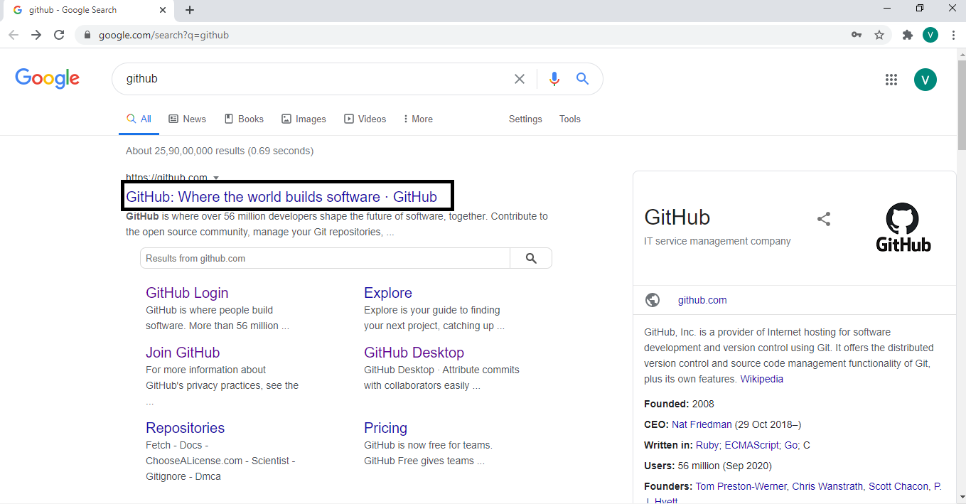

Step 2: Click on the Sign Up button to create an account.

**Name: - Vidhi Patel**

**Roll No: 61**

**Class: FYBSCIT**

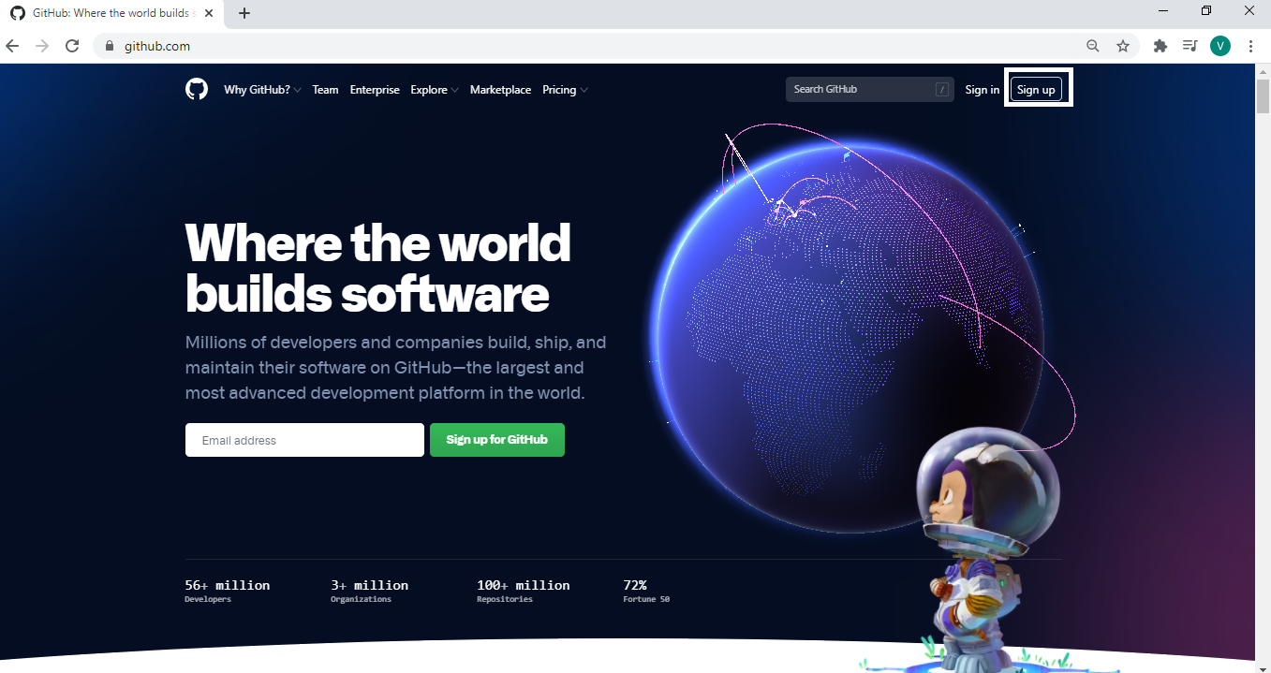

Step 3: After clicking on Sign Up button you will visit this page and fill the necessary detail.

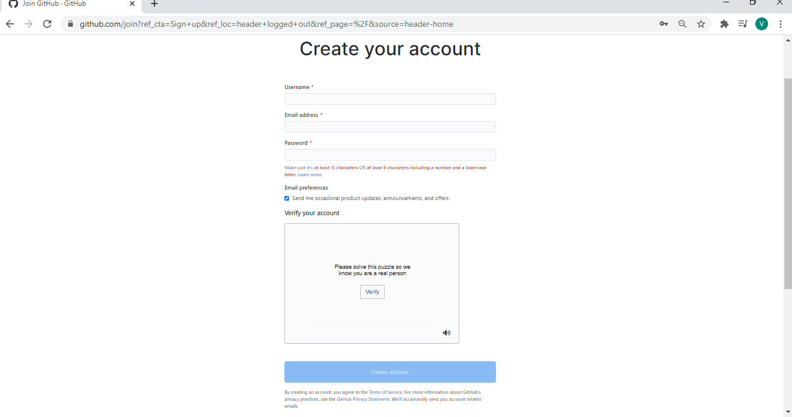

Click on Create Account

Verify you Email Address

Write password

Write Email Address

Write Name or username

**Name: - Vidhi Patel**

**Roll No: 61**

**Class: FYBSCIT**

Step 4: You will visit this page and click on **“Resend on Verification Email”** to Verify you Email Address.

(You will receive an Email from GitHub to verify) Now your account is created.

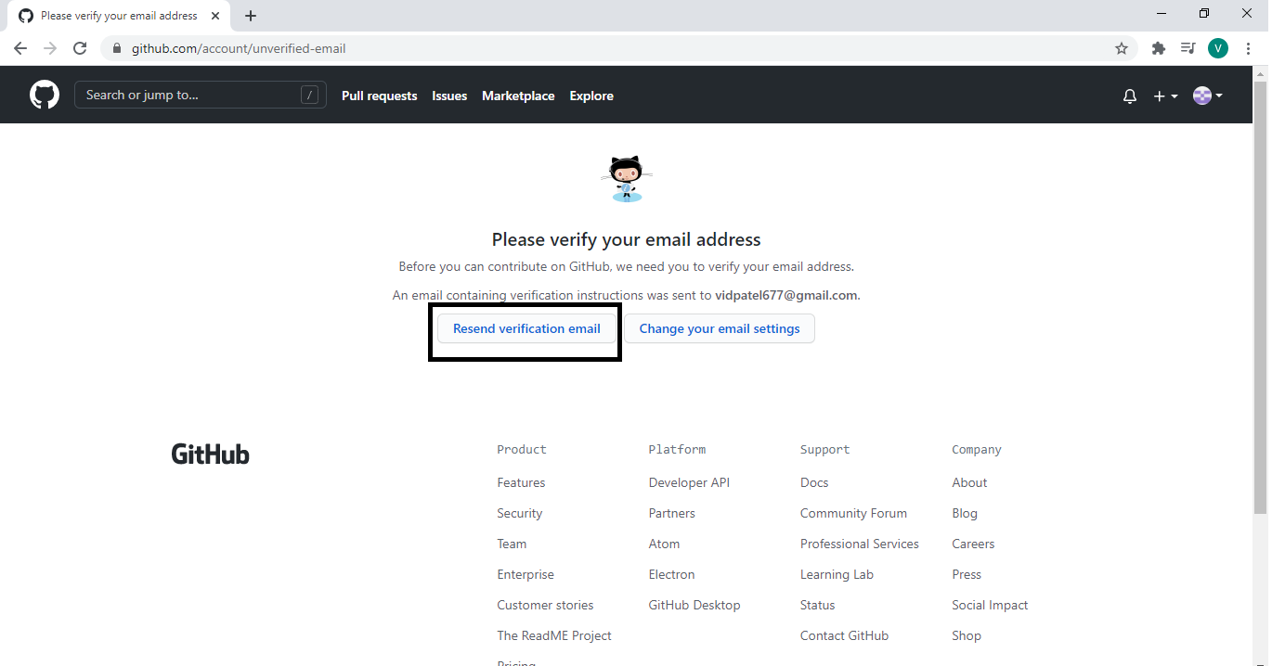

**b) Creating Repository**

Step 1: To Create Repository click on the **+ Button.**

**Name: - Vidhi Patel**

**Roll No: 61**

**Class: FYBSCIT**

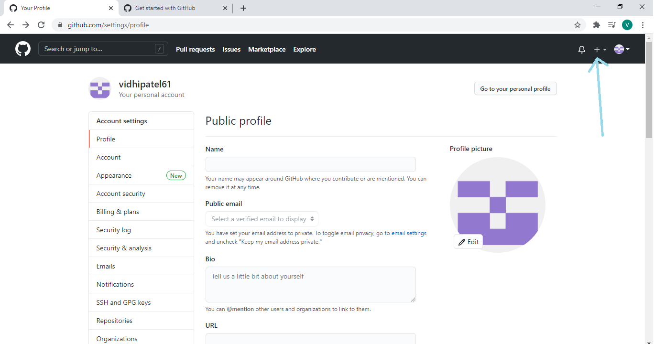

Step 2: Click on **New Repository to create.**

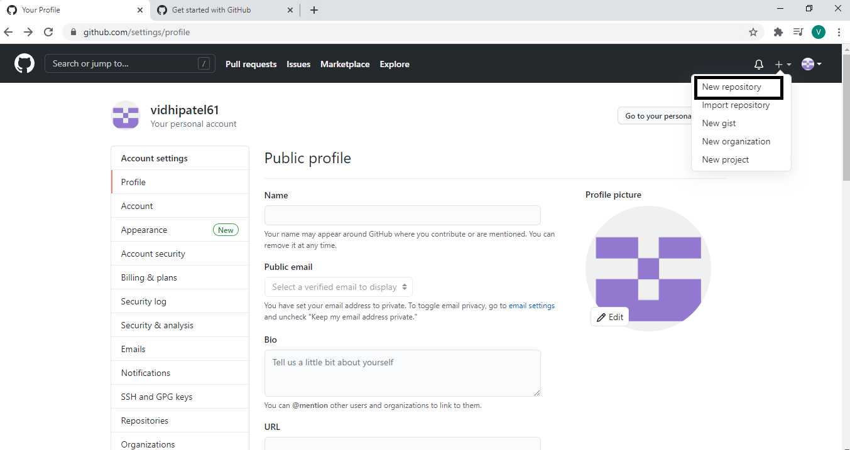

Step 3: You will visit this page to create a repository.

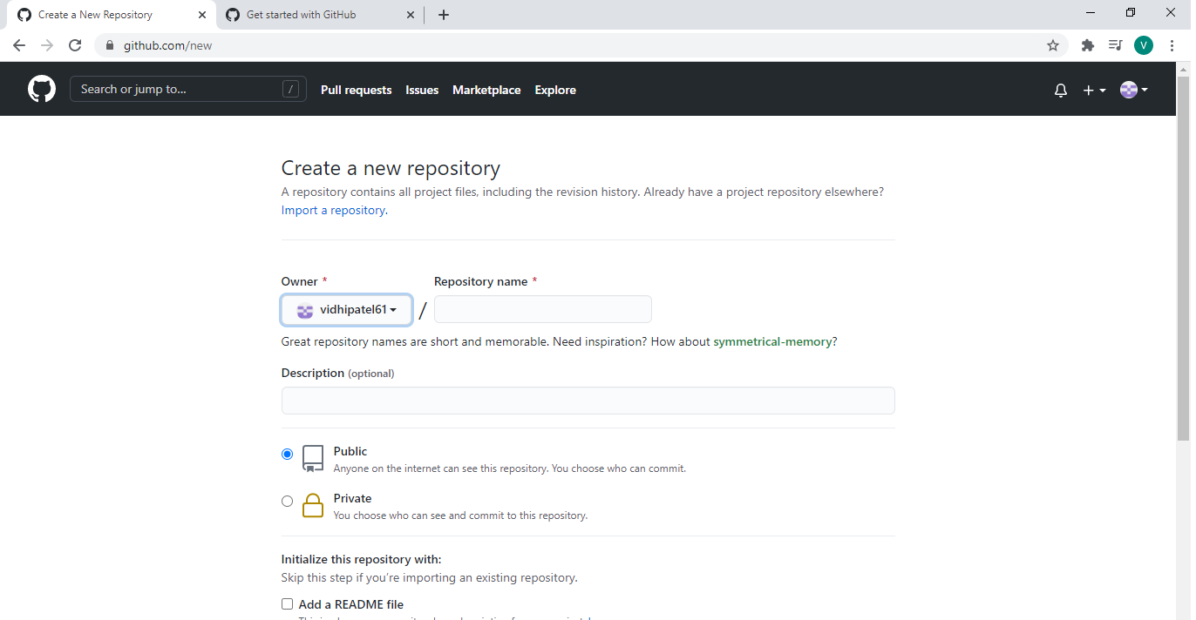

Step 4: After clicking on Create repository button you will visit this page and you have to give some details like repository name, the description about your repository click on the private or public button.

1) **Private:** If you want no one can access your repository then click on private button.

2**) Public**: If you want other people can access your repository then click on public button.

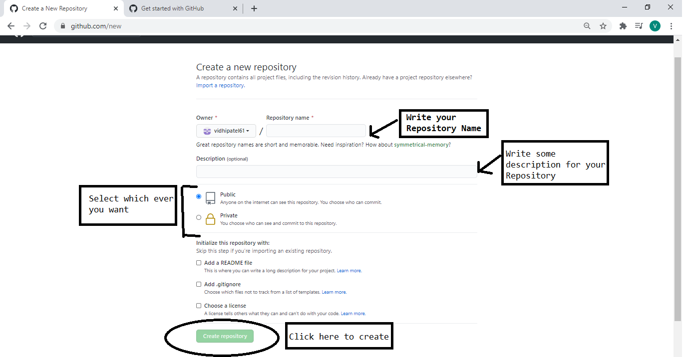

Step 5: On the last click of Create Repository you will visit this page

**Name: - Vidhi Patel**

**Roll No: 61**

**Class: FYBSCIT**

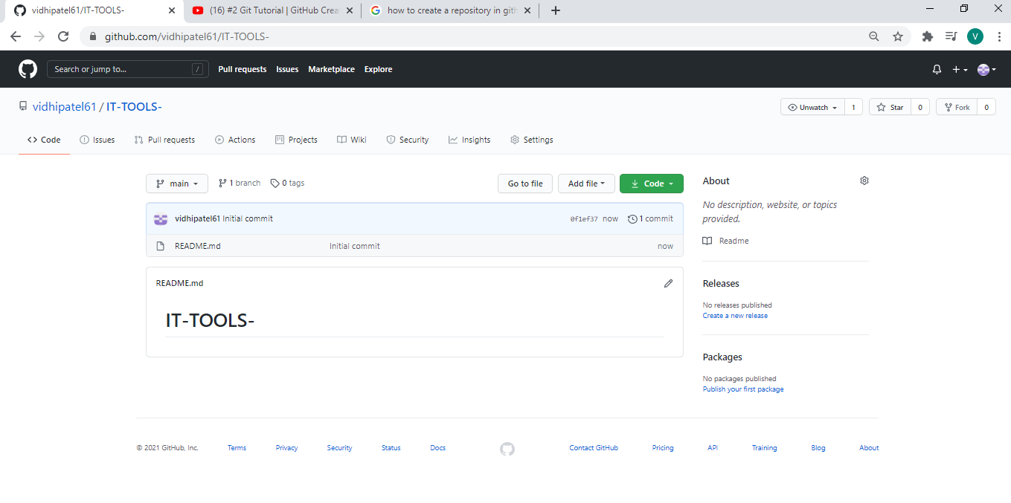

**c) Cloning repository**

Step 1: To Clone Repository click on the **Add File .**

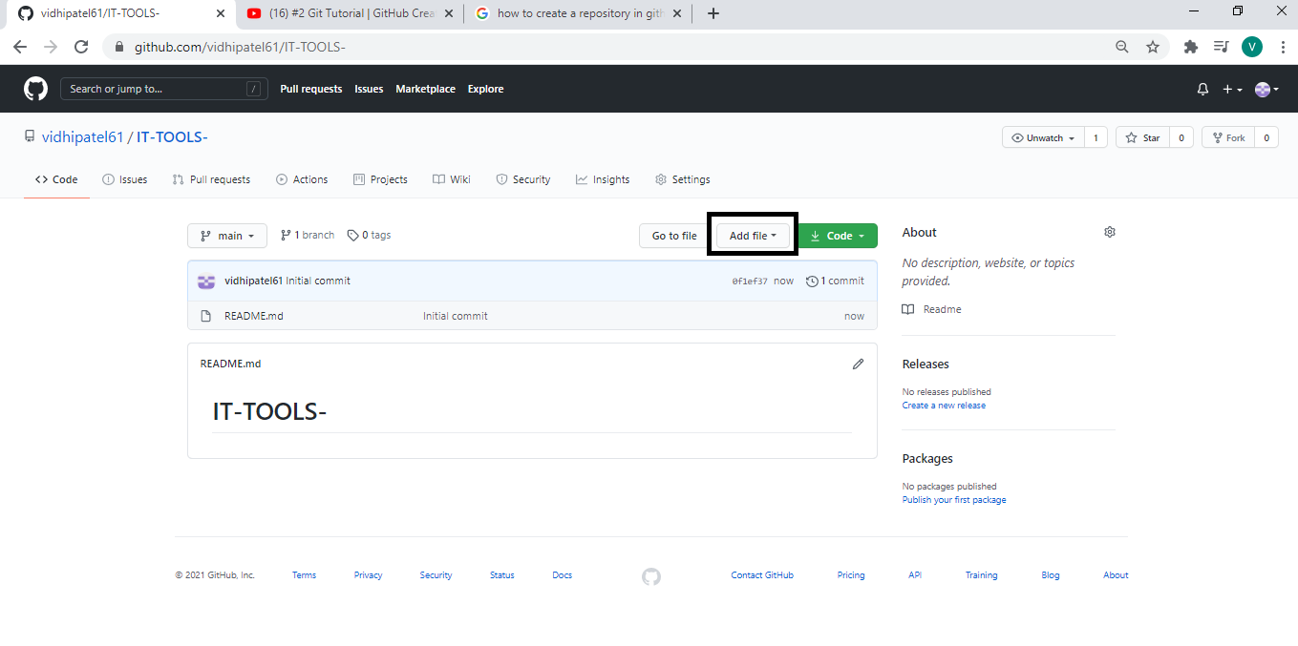

**Name: - Vidhi Patel**

**Roll No: 61**

**Class: FYBSCIT**

Step 2: You will visit this page and then click on **“Choose your files”** and choose the file which you want to upload in your Repository.

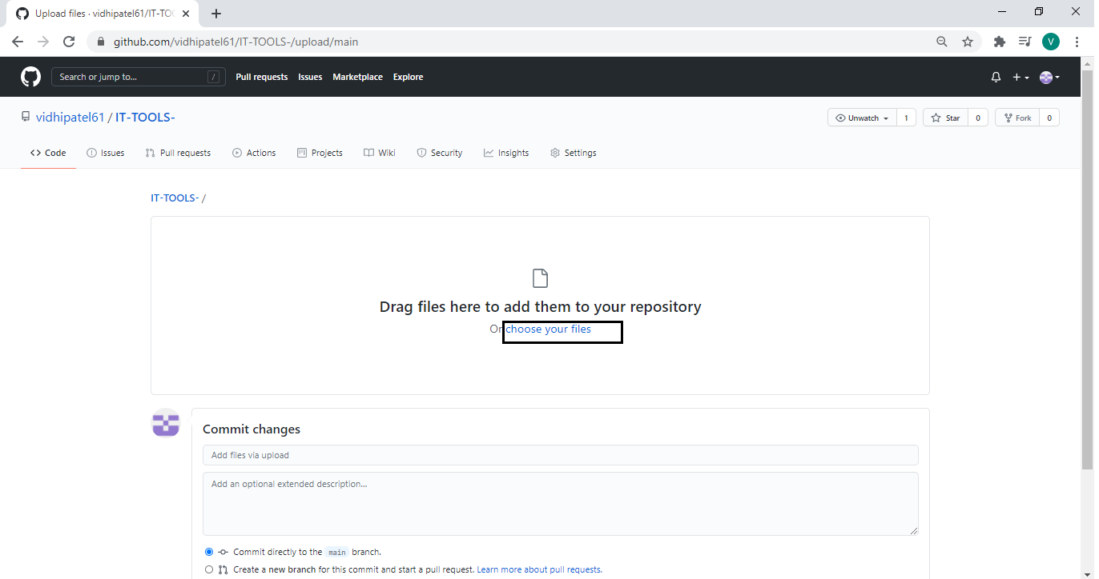

Step 3: Select the file which you want and click on open button and at last click on the commit changes button to save the changes.

**Name: - Vidhi Patel**

**Roll No: 61**

**Class: FYBSCIT**

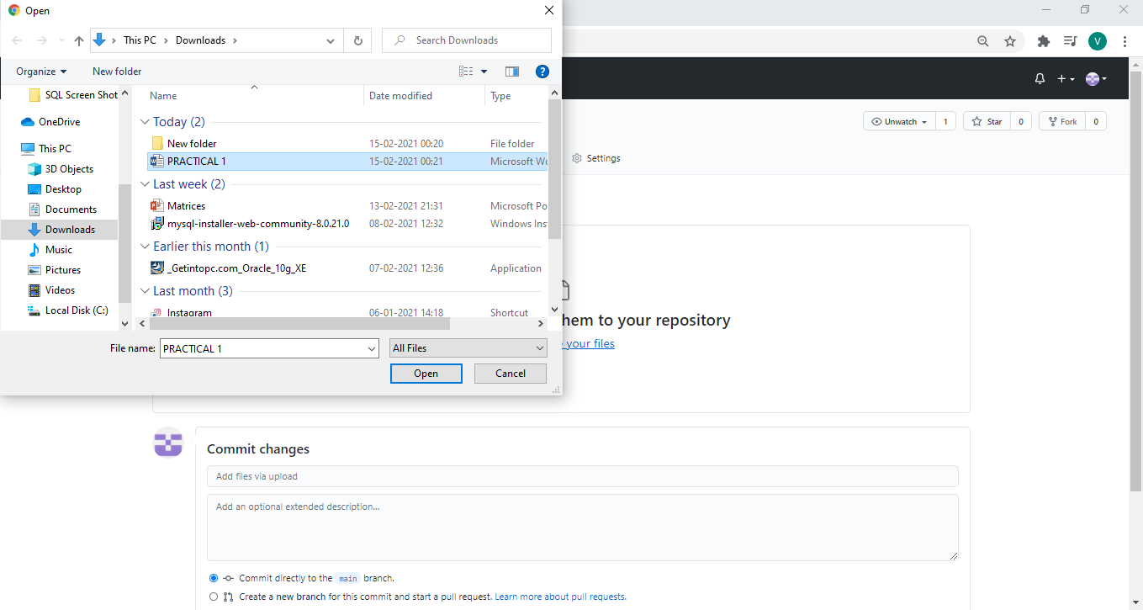

<https://github.com/vidhipatel61/IT-TOOLS-/upload/main>